**Computer Organization & Architecture Lab**

**Lab Report # 01**



Submitted By: **AWAIS SADDIQUI**

Registration No: **21PWCSE1993**

Section: **“A”**

“On my honor, as student at University of Engineering and

Technology, I have neither given nor received unauthorized.

assistance on this academic work”



**Student Signature: ______________**

Submitted to:

**Dr. Bilal Habib**

**Department of Computer Systems Engineering**

**University of Engineering and Technology, Peshawar.**

**ASSESSMENT RUBRICS COA LABS**

|  |  |  |  |  |
| --- | --- | --- | --- | --- |
| **LAB REPORT ASSESSMENT** | | | | |
| **Criteria** | **Excellent** | **Average** | **Nill** | **Marks Obtained** |
| 1. **Objectives of Lab** | All objectives of lab are properly covered  [Marks 10] | Objectives of lab are partially covered  [Marks 5] | Objectives of lab are not shown  [Marks 0] |  |
| 1. **MIPS instructions with**   **Comments and proper indentations.** | All the instructions are well written with comments explaining the code and properly indented  [Marks 20] | Some instructions are missing are poorly commented code  [Marks 10] | The instructions are not properly written  [Marks 0] |  |
| 1. **Simulation run without error and warnings** | The code is running in the simulator without any error and warnings  [Marks 10] | The code is running but with some warnings or errors.  [Marks 5] | The code is written but not running due to errors  [Marks 0] |  |
| 1. **Procedure** | All the instructions are written with proper procedure  [Marks 20] | Some steps are missing  [Marks 10] | steps are totally missing  [Marks 0] |  |
| 1. **OUTPUT** | Proper output of the code written in assembly  [Marks 20] | Some of the outputs are missing  [Marks 10] | No or wrong output  [Marks 0] |  |
| 1. **Conclusion** | Conclusion about the lab is shown and written  [Marks 20] | Conclusion about the lab is partially shown  [Marks 10] | Conclusion about the lab is not shown[Marks0]  [Marks 0] |  |
| 1. **Cheating** |  |  | Any kind of cheating will lead to 0 Marks |  |
| Total Marks Obtained:__________  Instructor Signature: ______________________ | | | | |

**Objectives:**

* ARITHMETIC OPERATION IN QTSPIM (ASSEMBPLY LANGUAGE)
* Addition
* Subtraction
* Division
* Multiplication
* Logical Operations

**Question # 1:**

**Output:**

**Question # 02.**

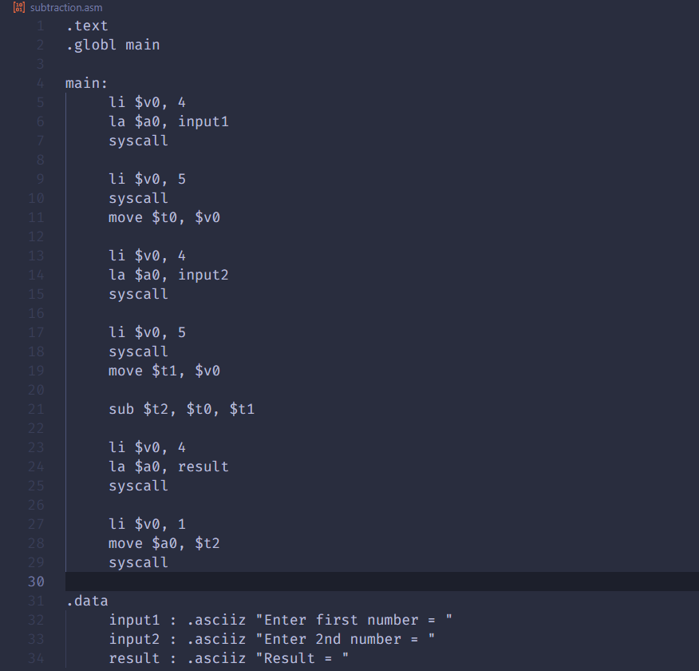

**Output:**

**Question # 03:**

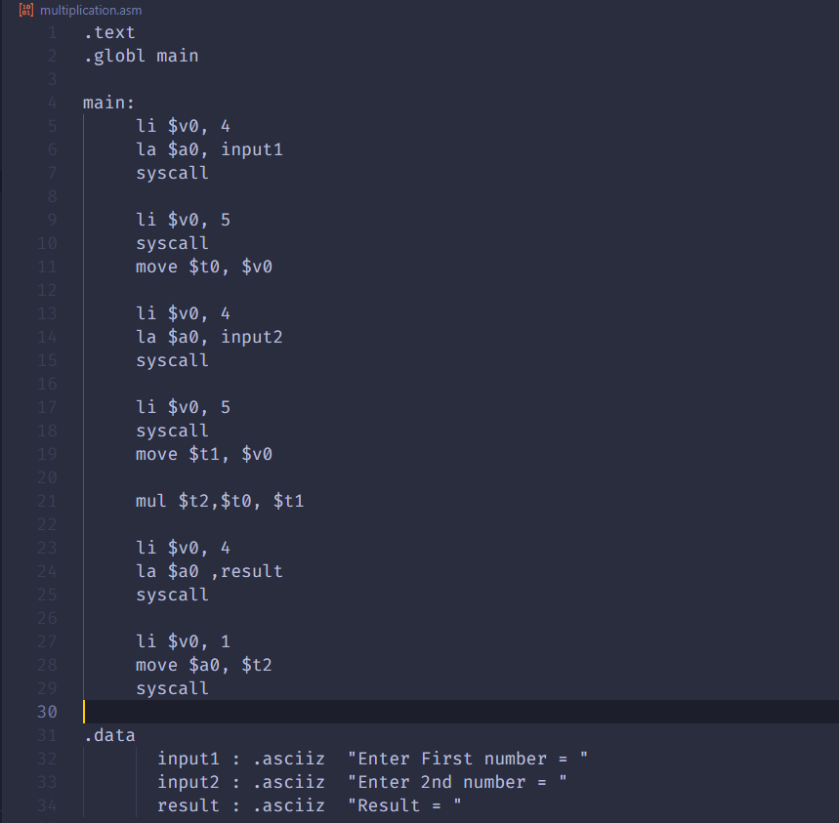

**Output:**

**Question # 04:**

**Output:**

**Question # 06:**

**Output:**

**Conclusion:**

In this lab, we learned how to write assembly language programs to perform arithmetic and logical operations in MIPS. We wrote assembly language programs to add, subtract, multiply, and divide two numbers. We also wrote assembly language programs to perform AND, OR, and NOT operations.